FARM SAFETY NEED ASSESSMENT - TEMPLATE
Working on a farm can be a dangerous job. This form can be used by you and/or your employee(s) to complete safety checks on your farm. When inspecting your farm, keep track of potential hazards and note whether there is a safety check in place for such hazards. Take note of hazards that need to be addressed. Keep the completed forms for follow-up, future reference, and inspections.
Area Inspected: __________________________________________________________________
POTENTIAL HAZARD (include hazard threat level) | Safe | Needs Correction | Date Corrected or Notes

Name of person conducting safety check: ________________________________ Date: ______________

For additional forms and resources, please visit thelandconnection.org/resources or umash.umn.edu/umash-farm-safety-check
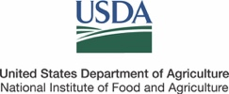
This material is based upon work supported by USDA/NIFA
under Award Number 2015-49200-26226

